3.

A --> B

B --> C

C --> D

C --> A

C --> G

E --> F

G --> C

G --> H

I --> H

I --> J

I --> K

J --> D

L --> D

M --> A

M --> N

N --> D

For the above graph, give the values for:

IN:

SCC:

OUT:

Tendrils:

Tubes:

Disconnected:

To calculate the values of the above graph which is in the form of a directed graph G=(V,E) where V are the vertices and E are the edges . To compute the values of bow-tie graph which is part of a web graph was given in Broder et al. paper (fig 9)[1]

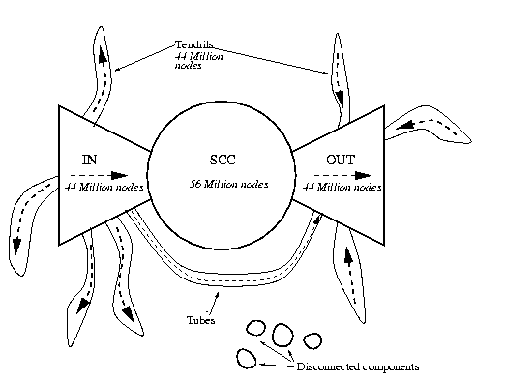

<http://www9.org/w9cdrom/160/160.html>

The main component in the graph is SCC as it is the “CORE” and rest of the values can be found using SCC.

So to calculate SCC several steps are followed which are suggested in [2]:

1 . Compute DFS for Graph G to calculate the fastest time for the nodes

DFSG

2. Reverse the arcs of the graph and compute DFS from the increasing order of fastest times on the graph

DFS (GT)

3.Then SCC is given by intersection of DFS on graph G and DFS on graph GT

SCC(S) = DFS(G) ∩ DFS (GT)

Computing DFS on Graph G , 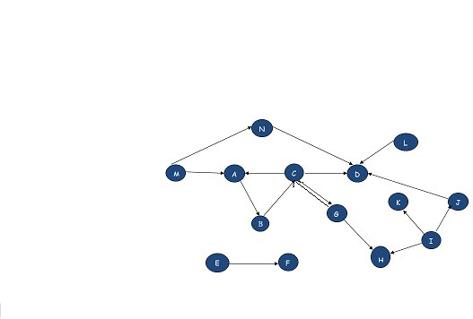

With the DFS the fastest times are calculated for each node .

Now reversing the arcs to compute the DFS on GT from the descending order of fastest times.

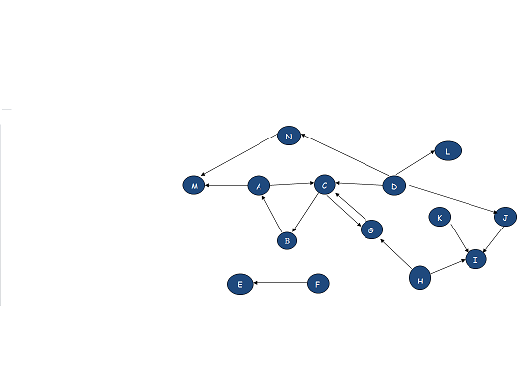

Calculating the SCC from both the steps fetches {A,B,C},{G}.

To compute rest of the entities

Let G = (V, A) be a digraph and let S be a strongly connected component of G. The bow-tie decomposition of G with respect to S consists of the following sets of nodes: [2]

SCC = S = **{A,B,C},{G}**

IN = {v Є V – S | S is reachable from v}= **{M}**

OUT = {v Є V – S | v is reachable from S}= **{D},{H}**

TUBES = {v Є V − S − IN − OUT |

v is reachable from IN and

OUT is reachable from v }= **{N}**

INTENDRILS = {v Є V − S|

v is reachable from IN and

OUT is not reachable from v} = **{None}**

OUTTENDRILS = {v Є V − S|

v is not reachable from IN and

OUT is reachable from v} = **{I,J},{L}**

TENDRILS = INTENDRILS + OUTTENDRILS **= {I,J} ,{L}**

OTHERS = V − S − IN – OUT = **{K},{E,F}**

Where **{E,F}** are DISCONNECTED